**EX.NO:11 DATE: 27.03.2025**

**BACKGROUND SUBTRACTION**

**Aim:**

To perform Background Subtraction using various techniques like Averaging, Frame differencing, MOG2, KNN for a video sample

**Algorithm:**

1. **Initialize Background Subtractors** (MOG2, KNN).
2. **Open Video File** and check if it's valid.
3. **Read the First Frame**, convert to grayscale, and initialize the average frame.
4. **Loop Through Frames**:

* Convert frame to grayscale.
* Compute **Frame Differencing** with the previous frame.
* Apply **MOG2 & KNN** background subtraction.
* Update **Averaging Technique** for background modeling.
* Stack and display results.

1. **Exit if 'q' is pressed**.
2. **Release video and close windows**.

**Code:**

import cv2  
import numpy as np  
from IPython.display import display, clear_output  
from PIL import Image, ImageDraw  
  
fgbg_mog2 = cv2.createBackgroundSubtractorMOG2()  
fgbg_knn = cv2.createBackgroundSubtractorKNN()  
  
cap = cv2.VideoCapture('video.mp4')  
  
if not cap.isOpened():  
 print("Error: Could not open video.")  
 exit()  
  
ret, prev_frame = cap.read()  
if not ret:  
 print("Error: Could not read video frame.")  
 cap.release()  
 exit()  
prev_frame = cv2.resize(prev_frame, (640, 480))  
prev_gray = cv2.cvtColor(prev_frame, cv2.COLOR_BGR2GRAY)  
  
avg_frame = np.float32(prev_gray)  
  
while cap.isOpened():  
 ret, frame = cap.read()  
 if not ret:  
 break  
   
 frame = cv2.resize(frame, (640, 480))  
 gray = cv2.cvtColor(frame, cv2.COLOR_BGR2GRAY)  
   
 frame_diff = cv2.absdiff(prev_gray, gray)  
 prev_gray = gray.copy()  
   
 fg_mask_mog2 = fgbg_mog2.apply(frame)  
 fg_mask_knn = fgbg_knn.apply(frame)  
   
 cv2.accumulateWeighted(gray, avg_frame, 0.02)  
 avg_result = cv2.absdiff(gray, cv2.convertScaleAbs(avg_frame))  
   
 combined = np.hstack((gray, frame_diff, avg_result, fg_mask_mog2, fg_mask_knn))  
   
 img_pil = Image.fromarray(cv2.cvtColor(combined, cv2.COLOR_GRAY2RGB))  
 draw = ImageDraw.Draw(img_pil)  
   
 clear_output(wait=True)  
 display(img_pil)  
   
 if cv2.waitKey(30) & 0xFF == ord('q'):  
 break  
  
cap.release()  
cv2.destroyAllWindows()

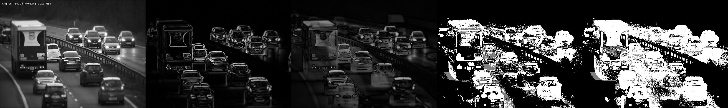

**Inference**

The code combines **Frame Differencing, MOG2, KNN, and Averaging** to detect motion and background changes in a video. Frame Differencing highlights moving objects but fails for stationary ones. MOG2 and KNN effectively extract the foreground but may introduce noise. The Averaging technique stabilizes the background over time. By integrating these methods, the approach enhances motion detection accuracy while reducing false positives, making it suitable for real-time video analysis.

**Result**

The code detects motion and background changes using **Frame Differencing, MOG2, KNN, and Averaging**, providing accurate foreground extraction and scene analysis.